We are adding new functionality on our concept car which is transforming it into an exoskeleton when not driving.

New functionalities are:

1) CFRS - Cold fusion reactor supervision (max. task call period 200us)

2) HSFODS - High speed foreign object detection system (max. task call period 400us)

3) MLMC - Magnetic levitation mode control (max. task call period 800us)

Task execution time is less then 90us for all three tasks.

Help us implement code (C programming) which calls controlling tasks in specified timing.

Microcontroller which runs code is equipped with up running timer that generates interrupts when CNTREG matches CMPREG.

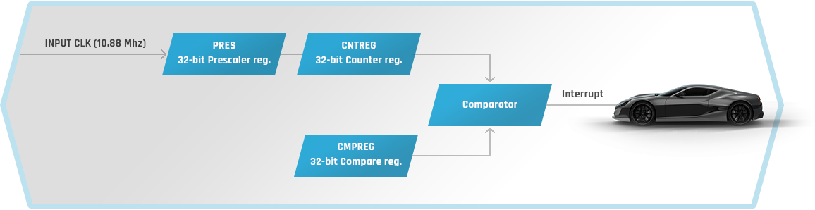

Write the dispatcher code and figure out the proper values of timer registers (PRES, CNTREG, CMPREG).

**void** **cfrs**(**void**); // First task prototype

**void** **hsfods**(**void**); // Second task prototype

**void** **mlmc**(**void**); // Third task prototype

**void** **Timer_Init** (**void**)

{

Stop_Timer();

CNTREG = ; //write correct init value here

CMPREG = ; //write correct init value here

PRES = ; //write correct init value here

Start_Timer();

}

uint32_t Time = 0;

**void** **Timer_ISR**()

{

Clear_Interrupt_Flag();

Time++;

Task_Dispatcher();

}

**void** **Task_Dispatcher**()

{

//write dispatcher code here

}